Power BI Capstone Project Documentation
Hospital Patient Analysis
Abstract
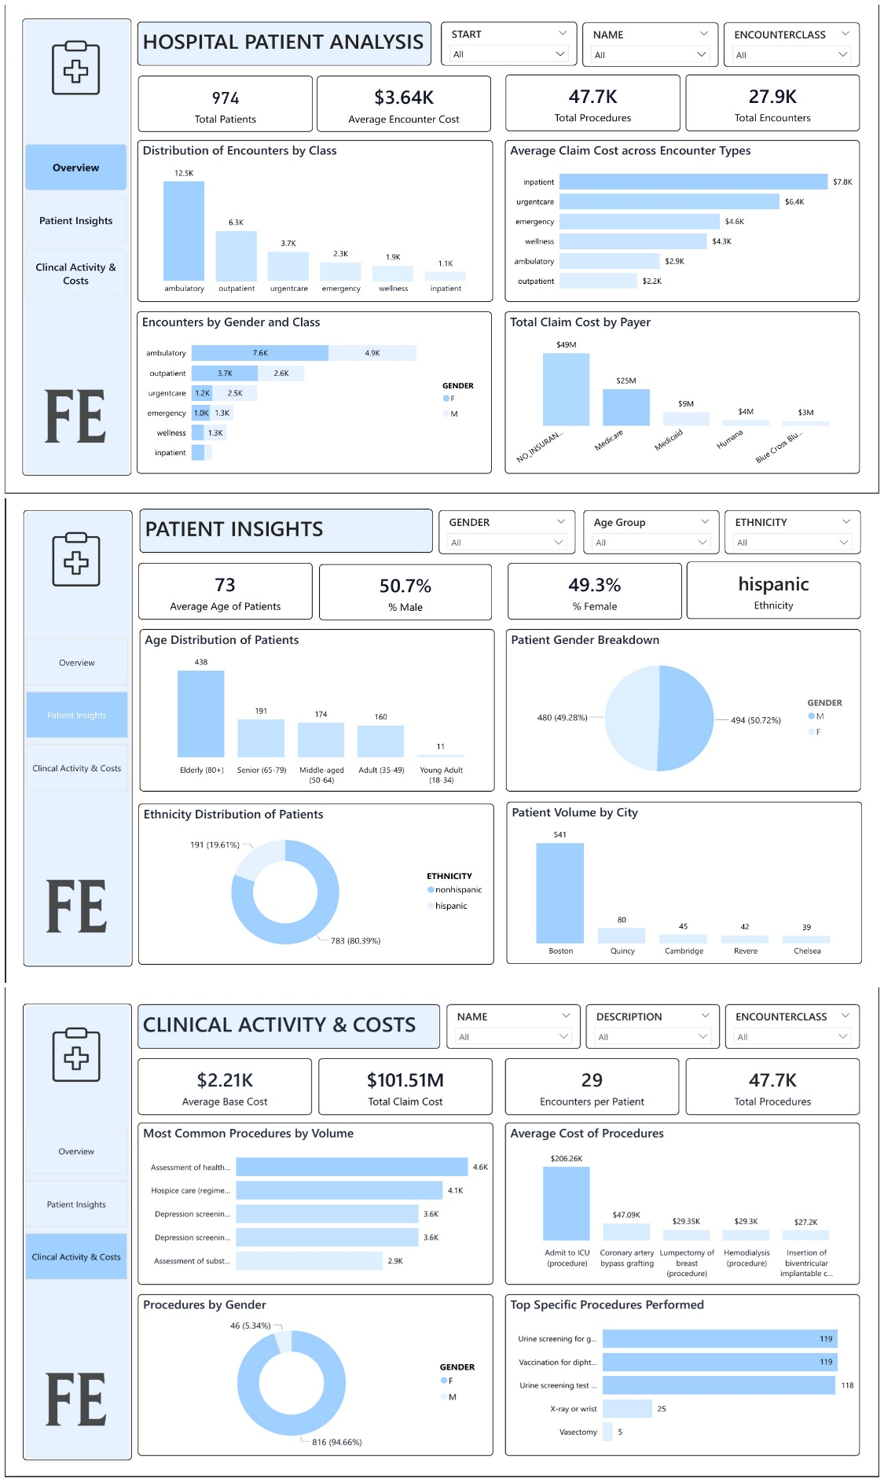
INTRODUCTION
This project evaluates hospital performance across operations, patients, and clinical activities using interactive Power BI dashboards. It tracks key indicators such as total claim costs, encounter volumes, procedure types, and patient demographics. By comparing encounter classes, financial trends, and demographic distributions, the dashboard provides stakeholders with a clear picture of how services are delivered, how costs are distributed, and how patient characteristics influence care. The goal is to connect patient activity with financial outcomes, guiding more effective hospital management and better patient care.
OBJECTIVE
The objective of this project is to analyze the hospital’s operational and financial performance across encounter classes, payer coverage, and patient demographics. It aims to highlight high-demand and high-cost areas such as procedures, encounter reasons, and inpatient services, while also identifying underperforming segments. By connecting clinical activity with financial outcomes, the dashboard is designed to guide strategic decisions that improve service efficiency, optimize resource allocation, strengthen revenue generation, and ultimately enhance the quality of patient care.
PROBLEM STATEMENT
Hospitals generate large amounts of data on patients, encounters, procedures, and finances, but this information often exists in silos. Without a unified view, it is difficult for decision makers to:
- Monitor operational efficiency (encounters, procedures, utilization).
- Identify top drivers of cost (by encounter class, procedure, or payer).
- Understand patient demographics and geographic reach.
- Balance clinical demand with financial sustainability.
This lack of integration can result in poor resource allocation, hidden cost burdens, and missed opportunities for preventive care.
POTENTIAL QUESTIONS
OVERVIEW PAGE
- Which encounter classes (ambulatory, outpatient, inpatient, etc.) are most common?
- Which encounter class has the highest average claim cost?
- How do encounter classes vary by gender (male vs female)?
- Which payers (e.g., Medicare, Medicaid, uninsured) are covering the largest share of costs?
PATIENT INSIGHTS
- What is the age distribution of patients?
- What is the gender breakdown of patients?
- What is the ethnicity distribution (Hispanic vs non-Hispanic)?
- Which cities contribute the most patients?

CLINICAL ACTIVITY & COSTS
- What are the most common procedures/encounter types performed?
- Which procedures are the most expensive on average?
- How are procedures distributed across male and female patients?
- What are the top specific procedures (e.g., screenings, vaccinations, X-rays)?
DATA SOURCE
The Hospital Patient Record Dataset was gotten from Maven Analytics Data Playground
DATA DESCRIPTION
encounter table
- id → unique encounter identifier
- start, stop → start and stop timestamps of the encounter
- patient → patient id (links to patient’s dataset)
- organization → organization id (links to organizations dataset)
- payer → payer id (links to payer’s dataset)
- encounterclass → type of visit (inpatient, outpatient, emergency, etc.)
- code, description → medical coding and description of encounter
- base_encounter_cost → base cost of the encounter
- total_claim_cost → total amount claimed for reimbursement
- payer_coverage → portion of claim covered by payer
- reasoncode, reasondescription → code and description for reason of visit

Organization Table
- id → organization identifier
- name → organization name
- address, city, state, zip → location information
- lat, lon → geographic coordinates

Payers Table
- id → payer identifier
- name → payer/insurance company name
- address, city, state_headquartered, zip → company headquarters info
- phone → contact number

Patients Table
- id → patient identifier
- birthdate, deathdate → date of birth and death (if applicable)
- prefix →name prefix, such as mr., mrs., dr., etc.
- suffix → name suffix, such as phd, md, jd, etc.
- first, last, maiden → patient’s names
- marital → marital status
- race, ethnicity → race and ethnicity
- gender → gender
- birthplace → birth location
- address, city, state, county, zip → current address info
- lat, lon → geographic coordinates

Procedure Table
- start, stop → time of procedure
- patient → patient id (links to patient’s dataset)
- encounter → encounter id (links to encounters dataset)
- code, description → medical coding and description of the procedure
- base_cost → base cost of the procedure
- reasoncode, reasondescription → reason for procedure

DATA CLEANING AND TRANSFORMATION
The hospital patient record dataset was first gotten from Maven Analytics Data Playground as agreed by my group after which it was imported to power bi and then the following was done in power query:
- Checking for duplicates
we checked for duplicates, and none was found
- Handling missing values
we checked for blanks, and none was found
- Checking data Types
We checked data types and changed it where necessary
After all this was done i closed and loaded after which I created my measures and column
- Creating measures
I created a new table called calculations and then I created some measures for my analysis, and they are: Total Patients, Total Encounters, Total Procedures, Total Claim Cost, Average Encounter Cost, Average Age, Male Patients, Female Patients, % Male, % Female, Encounters per Patient, Total Payer Coverage, YoY Patient Growth %, Number of Patient previous and current year
- Creating Calculated Columns
I created some calculated columns for my analysis, and they are: Age, Age Group, Age Group Sort
I gave the powerbi page a background colour and I also created a textbox for my page title and gave it a background colour.

Statistical Analysis

KPI Cards
I clicked on the kpi cards from the visualization pane and added the column I wanted to show on my kpi cards for the three pages then I did the same thing for my slicers. After all this was done, I added my charts and a page navigator, and I gave my page navigator color for when selected and when in default.

ANALYSIS

OVERVIEW PAGE
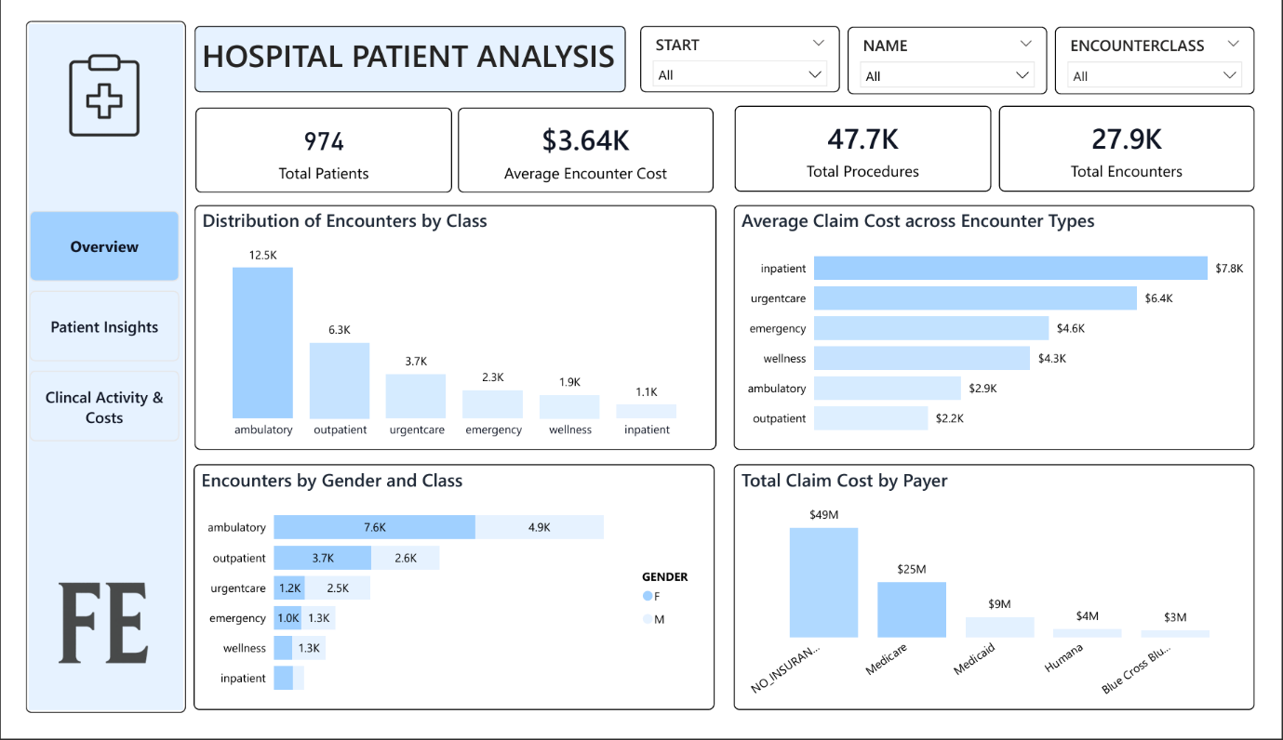

Analysis Question
- Which encounter classes (ambulatory, outpatient, inpatient, etc.) are most common?
- Which encounter class has the highest average claim cost?
- How do encounter classes vary by gender (male vs female)?
- Which payers (e.g., Medicare, Medicaid, uninsured) are covering the largest share of costs?
Approach to answering question
After creating all my measures, I clicked on the chart I wanted from the visualization pane after which I added the necessary columns and I used conditional formatting from the format pane for the colors and I also edited the height and width from the format pane properties section and I made sure all the charts are well aligned and then I added my slicers also I made sure they were well aligned.

Insights
- The hospital has 974 patients, with 27.9K encounters and 47.7K procedures.
- Ambulatory (12.5K) and outpatient (6.3K) dominate encounter volume, while inpatient has the lowest (1.1K).
- Inpatient encounters are the costliest ($7.8K each), while outpatient is the cheapest ($2.2K).
- Uninsured patients account for nearly half of all claim costs ($49M), while Medicare covers the next largest share ($25M).
- Gender differences appear in encounter classes: female patients drive more outpatient visits.
PATIENT INSIGHTS
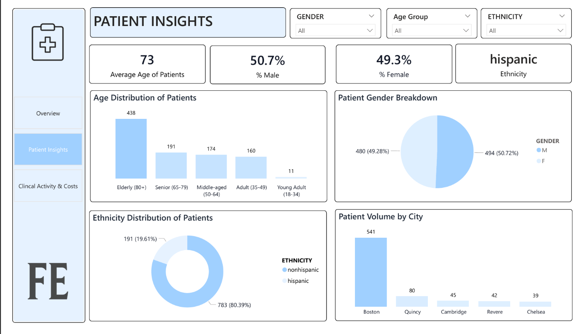
Analysis Question
- What is the age distribution of patients?
- What is the gender breakdown of patients?
- What is the ethnicity distribution (Hispanic vs non-Hispanic)?
- Which cities contribute the most patients?
Approach to answering question
After creating all my measures, I clicked on the chart I wanted from the visualization pane after which I added the necessary columns and I used conditional formatting from the format pane for the colors and I also edited the height and width from the format pane properties section and I made sure all the charts are well aligned and then I added my slicers also I made sure they were well aligned.

Insights
- Elderly patients (80+) dominate with 438 cases, while young adults (18–34) are the smallest group with only 11 cases.
- The patient base is almost evenly split, with 50.7% male and 49.3% female.
- Non-Hispanic patients make up the majority (80.4%), while Hispanic patients account for 19.6%.
- Boston leads with 541 patients, far higher than Quincy (80) and other smaller cities.
When filters are applied:
- By Age Group: Seniors and elderly patients shift encounters toward Inpatient and Emergency, increasing average claim cost.
- By Gender: Female filters increase Outpatient and Wellness visits, while male filters increase Urgent Care and Emergency visits.
- By Payer: Medicare filters show concentration in elderly care, while Commercial payer filters show more Outpatient services.
- By City: Boston dominates overall; filtering by smaller cities changes the mix, often raising Emergency proportions.
CLINICAL ACTIVITY & COSTS
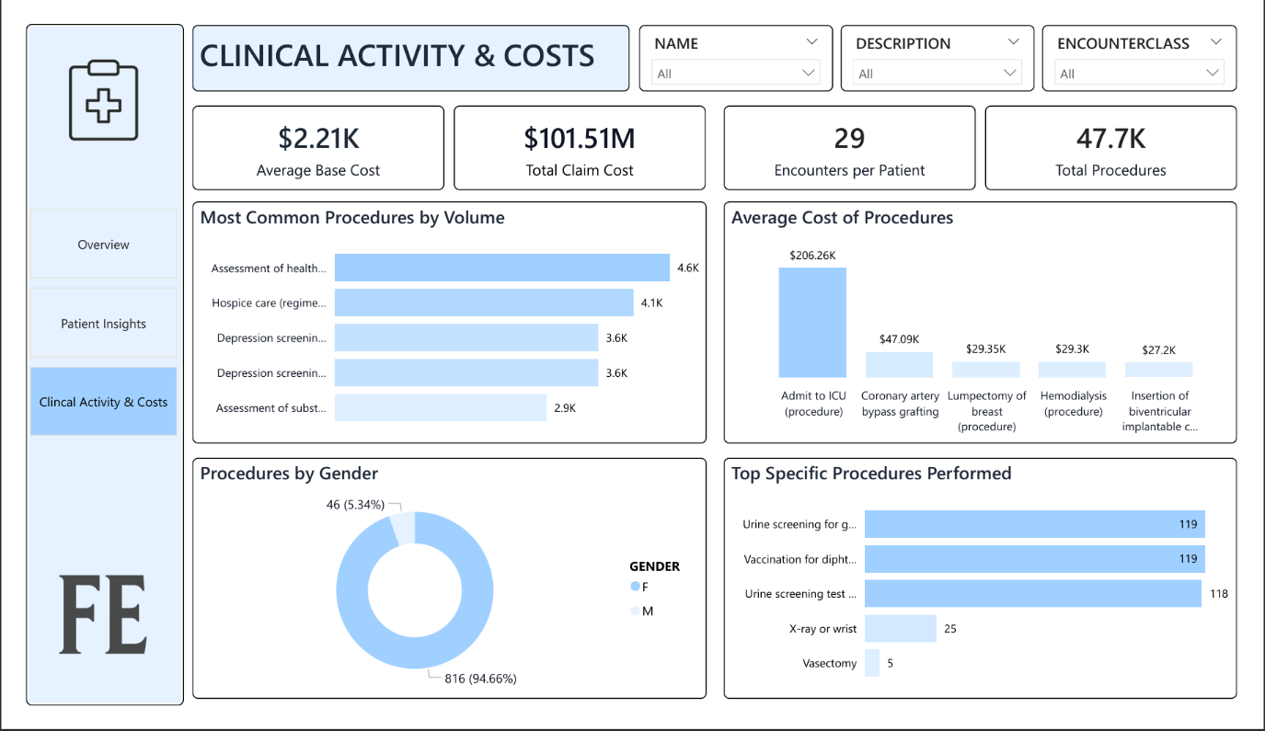
Analysis Question
- What are the most common procedures/encounter types performed?
- Which procedures are the most expensive on average?
- How are procedures distributed across male and female patients?
- What are the top specific procedures (e.g., screenings, vaccinations, X-rays)?

Approach to answering question
After creating all my measures, I clicked on the chart I wanted from the visualization pane after which I added the necessary columns and I used conditional formatting from the format pane for the colors and I also edited the height and width from the format pane properties section and I made sure all the charts are well aligned and then I added my slicers also I made sure they were well aligned.
Insights
- The average base cost is $2.21K.
- Patients average 29 encounters each, showing very high utilization.
- Most common procedures: assessment of health and social care needs (4.6K), hospice care (regime/therapy): 4.1K, depression screening using patient questionnaire two-item score (3.6K), substance use assessments (2.9K).
- Most expensive procedures: ICU admission ($210K), coronary artery bypass graft ($50K), lumpectomy of breast ($30K).
- Female patients account for 95% of procedure volumes, reflecting women’s health services.
- Routine urine screenings (118–119 each) and vaccinations (119) dominate while X-rays (25) and vasectomies (5) are far less frequent, highlighting the hospital’s tilt toward preventive and diagnostic screenings over surgical or imaging interventions.

Visualization
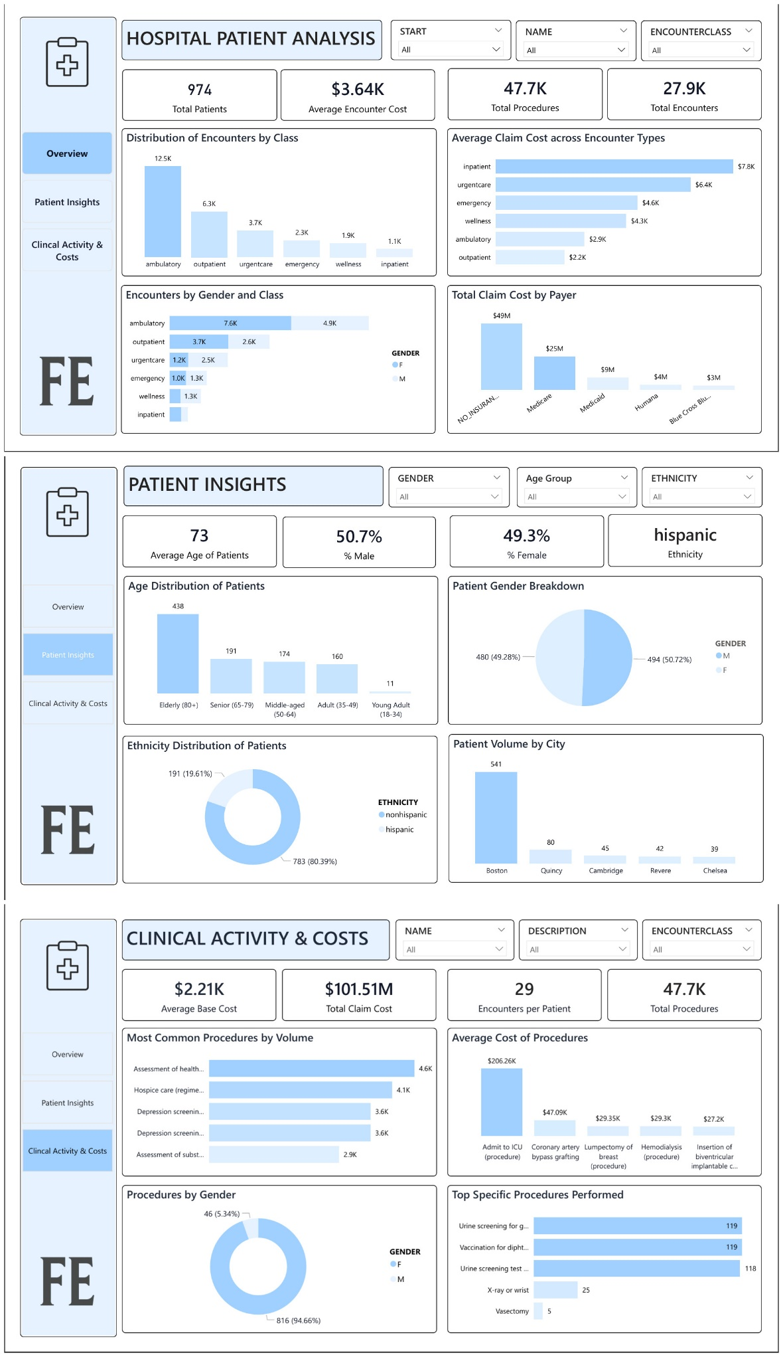
Interpretation of Results
- The hospital recorded 974 patients, 27.9K encounters, and 47.7K procedures, generating a total claim cost of $101.5M.
- Ambulatory (12.5K) and outpatient (6.3K) dominate encounter volume, while inpatient has the lowest (1.1K).
- Inpatient encounters are the costliest ($7.8K each), while outpatient is the cheapest ($2.2K).
- Uninsured patients account for nearly half of all claim costs ($49M), creating significant financial risk; Medicare is the second-largest payer ($25M).
- Gender differences appear, female patients drive more outpatient visits and procedures, while male patients contribute more to urgent/emergency care.
- The average patient age is 73 years, with 64% of patients classified as Seniors (65–79) or Elderly (80+).
- Gender distribution is nearly equal (50.7% male, 49.3% female).
- Ethnicity is skewed toward non-Hispanic (80%), with Hispanic patients making up 20%.
- Boston accounts for over half of patient volume (541 patients), while Quincy, Cambridge, and Revere contribute smaller proportions, highlighting geographic concentration.
- Most common procedures include health and social care assessments (4.6K), hospice care (4.1K), depression screening (3.6K), and substance use assessments (2.9K).
- High-cost procedures such as ICU admission ($210K), coronary artery bypass graft ($50K), and lumpectomy ($30K) are rare but drive a disproportionate share of financial burden.
- Clinical activity is heavily skewed toward female patients (95% of procedures), indicating strong demand for women’s health services.
Filtering provides deeper insights:
- By Age Group: Seniors and elderly patients shift demand toward Inpatient and Emergency care, increasing average costs.
- By Gender: Female filters emphasize outpatient and screening services; male filters highlight acute and emergency procedures.
- By Payer: Medicare aligns with older patients and costly inpatient care; Commercial payers show younger patients with lower-cost outpatient services.
- By City: Boston dominates, but smaller cities reveal narrower service mixes, sometimes with heavier reliance on emergency visits.
Overall, the results show that the hospital serves an aging, high-utilization population with financial exposure from uninsured patients and costly inpatient services. Preventive and community-based care is strong, but better payer engagement, geriatric care management, and efficiency improvements are needed to reduce cost pressure and improve sustainability.

RECOMMENDATION
Financial Risk Management
  - Encourage uninsured patients to enroll in coverage programs to reduce their out-of-pocket burden and strengthen hospital revenue stability.”
  - Explore insurance enrollment drives, financial counseling, or partnerships with community/government programs to improve coverage.
  - Monitor inpatient and ICU procedures, which are major cost drivers, and evaluate opportunities for bundled payments or care standardization.
Geriatric and Chronic Care Programs
- Expand dedicated services for seniors and elderly patients (65+), who represent most of the patient base.
- Focus on preventive management of chronic conditions (cardiac, metabolic, mobility) to reduce costly hospitalizations.
- Increase access to home-based or community care for elderly patients to relieve inpatient demand.
Preventive and Mental Health Services
- Scale up existing screening programs (depression, substance use, wellness checks) since they are high in volume and relatively low in cost.
- Strengthen women’s health programs given the very high utilization among female patients.
- Integrate behavioral health and chronic disease screenings into primary care to catch risks earlier.
Geographic Outreach & Service Balance
- Patient volume is heavily concentrated in Boston; consider outreach clinics or partnerships in smaller cities (Quincy, Cambridge, Revere) to balance access.
- Expand service availability outside Boston to reduce over-reliance on a single hub.
- Tailor outreach efforts by city demographics (ethnicity mix, payer coverage) for targeted impact.
Data-Driven Operations
- Use encounter and procedure cost analytics to identify underperforming service lines.
- Track payers mix changes over time to proactively negotiate reimbursement contracts.
- Standardize reporting so leaders can monitor cost per encounter, procedure efficiency, and payer coverage in real-time.
Conclusion
- The hospital is currently serving a predominantly elderly population, resulting in high demand for inpatient and chronic care services.
- Financial exposure is significant due to uninsured patients, who contribute almost half of all claim costs, and high-cost inpatient procedures such as ICU admissions.
- At the same time, the hospital shows strength in preventive screenings, hospice care, and women’s health services, which are cost-effective and widely utilized.
- Geographic concentration in Boston presents both an advantage in efficiency and a risk in over-reliance, while smaller cities remain underserved.
- To ensure sustainability, the hospital must improve payer coverage, expand geriatric and preventive programs, and balance service delivery across geographies.
In summary: With better financial risk management, stronger elderly and preventive care, and targeted outreach, the hospital can improve patient outcomes, optimize costs, and achieve long-term operational stability.

